SIMATS ENGINEERING
ASSESSMENT TOOL 2

COURSE NAME: Database Management Systems
COURSE CODE: CSA05

COURSE OUTCOME COVERED

CO3: Analyze relational databases using functional dependencies, normalization (1NF to 5NF), and key constraints to identify redundancy and ensure data integrity. (BL2, BL3)

Activity Tool : Case Study (Medium)
Assessment Tool Weightage: 30%

QUESTIONS:
- Analyze the case: An online shopping platform stores Order(OrderID, CustID, CustName, ProdID, ProdName, Qty, Price). Identify FDs and normalize to 3NF.

ANSWER:

Online Shopping — 3NF
FDs:
- OrderID → CustID
- CustID → CustName
- ProdID → ProdName, Price
- (OrderID, ProdID) → Qty
Decomposition:
- Customer(CustID, CustName)
- Product(ProdID, ProdName, Price)
- Orders(OrderID, CustID)
- OrderDetails(OrderID, ProdID, Qty)
Answer: The relation is normalized to 3NF.

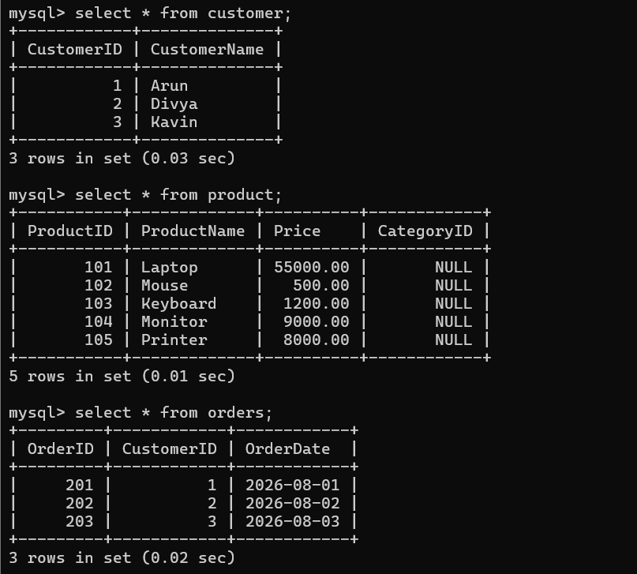

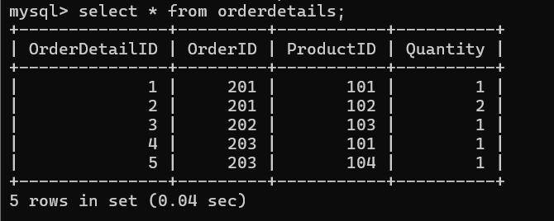
- A hospital maintains Patient(PID, PName, DocID, DocName, Specialization, WardNo, WardName). Identify anomalies and normalize to BCNF.
ANSWER:
Hospital — BCNF
FDs:
- PID → PName, DocID, WardNo
- DocID → DocName, Specialization
- WardNo → WardName
Anomalies:
- Insertion anomaly
- Update anomaly
- Deletion anomaly
Decomposition:
- Patient(PID, PName, DocID, WardNo)
- Doctor(DocID, DocName, Specialization)
- Ward(WardNo, WardName)
Answer: The decomposition is in BCNF.
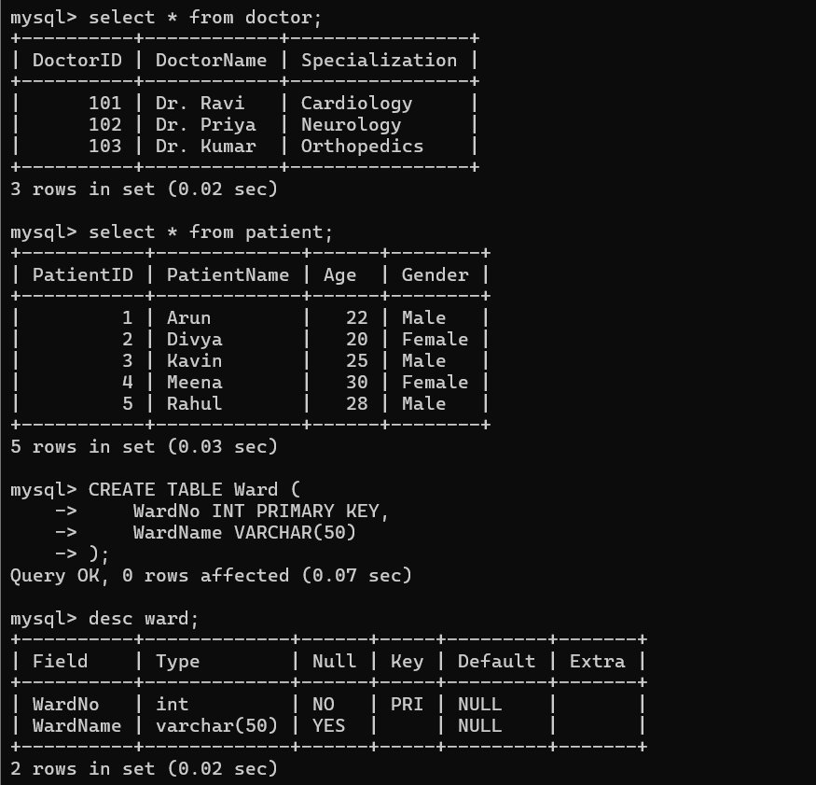

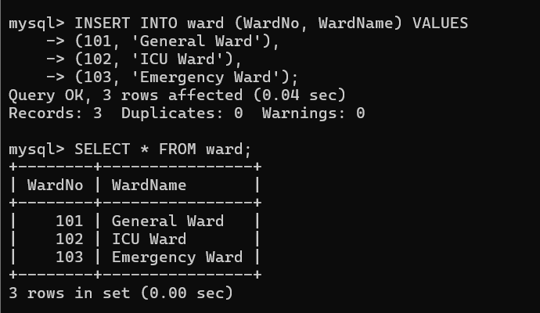
- Case study: A university stores Enrollment(SID, SName, CourseID, CourseName, Faculty, Grade). Analyze FDs and apply 2NF decomposition.

ANSWER:

University Enrollment — 2NF
FDs:
- SID → SName
- CourseID → CourseName, Faculty
- (SID, CourseID) → Grade
Candidate Key: (SID, CourseID)
Decomposition:
- Student(SID, SName)
- Course(CourseID, CourseName, Faculty)
- Enrollment(SID, CourseID, Grade)
Answer: Partial dependencies are removed; the relations are in 2NF.

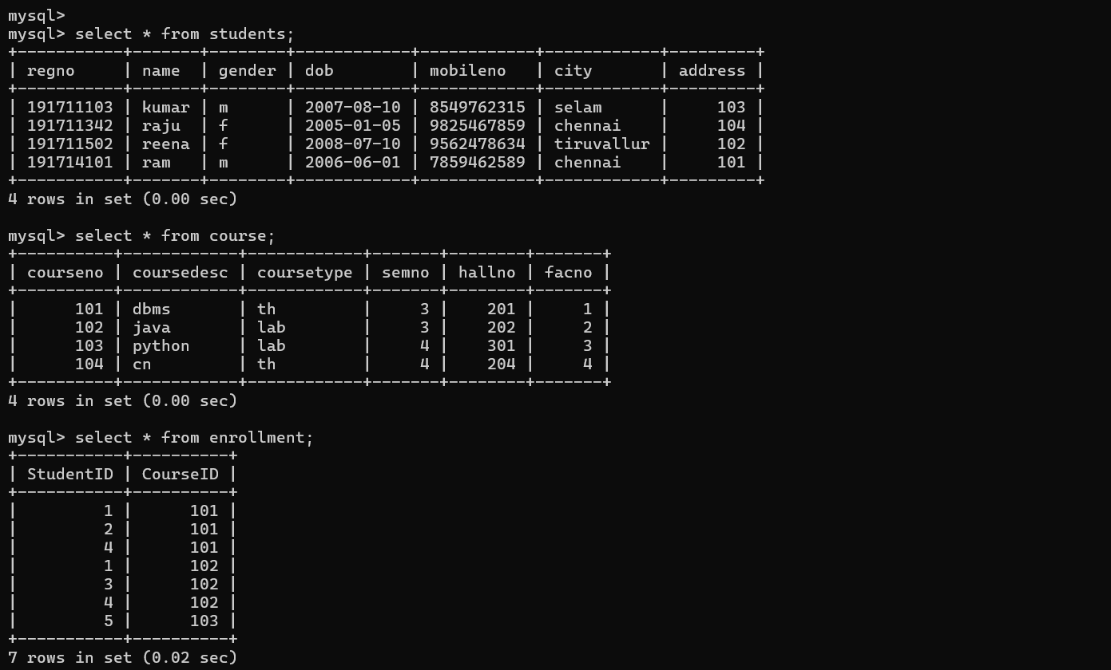

- Given the airline booking case: Booking(FlightNo, PassID, PassName, Seat, DeptCity, ArrCity, Date). Normalize up to BCNF.

ANSWER:
Airline Booking — BCNF
FDs:
- PassID → PassName
- FlightNo → DeptCity, ArrCity
- (FlightNo, Date, Seat) → PassID
- (FlightNo, Date, PassID) → Seat
Decomposition:
- Passenger(PassID, PassName)
- Flight(FlightNo, DeptCity, ArrCity)
- Booking(FlightNo, Date, Seat, PassID)
Answer: The decomposition is in BCNF.
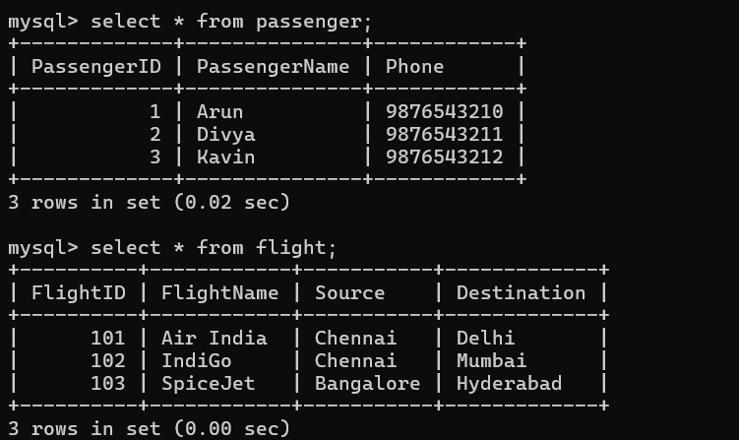

- Analyze an HR system schema for a multinational company. Identify all functional and transitive dependencies and normalize to 3NF.
ANSWER:

HR System — 3NF
FDs:
- EmpID → EmpName, DeptID, ManagerID, JobID, Salary
- DeptID → DeptName
- ManagerID → ManagerName
- JobID → JobTitle
Transitive Dependencies:
- EmpID → DeptID → DeptName
- EmpID → ManagerID → ManagerName
- EmpID → JobID → JobTitle
Decomposition:
- Employee(EmpID, EmpName, DeptID, ManagerID, JobID, Salary)
- Department(DeptID, DeptName)
- Manager(ManagerID, ManagerName)
- Job(JobID, JobTitle)
Answer: Transitive dependencies are removed; the design is in 3NF.
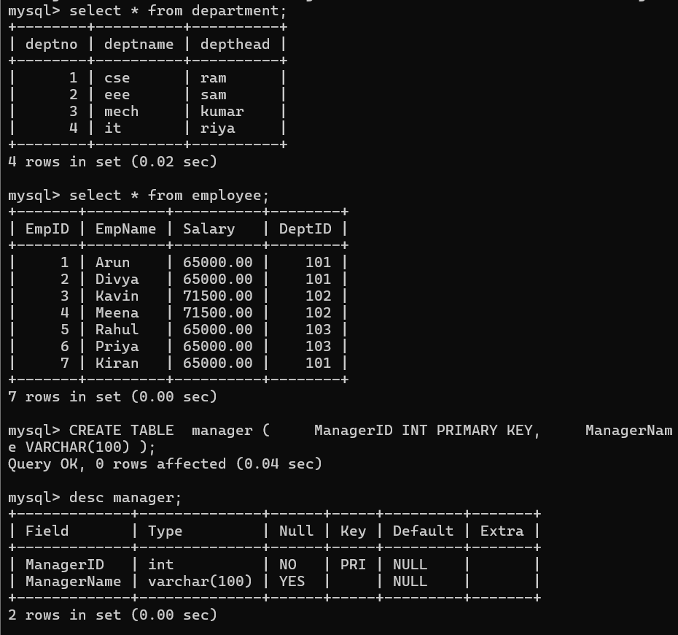
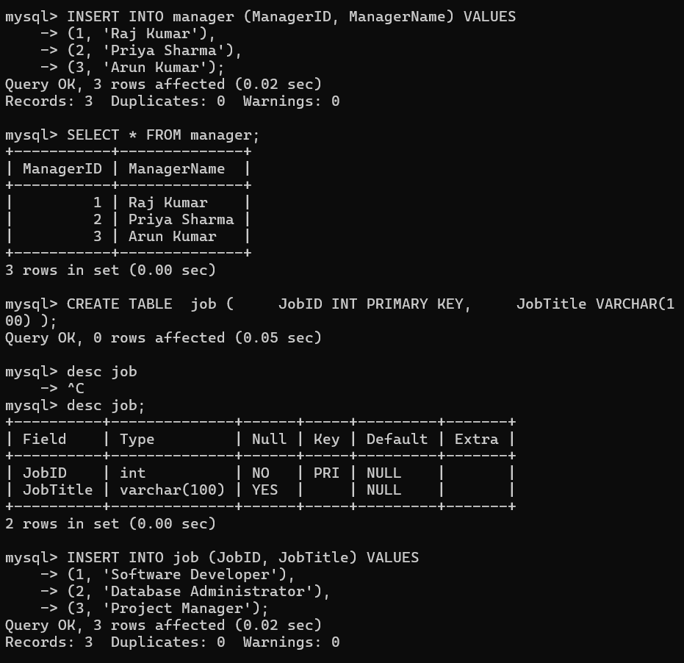

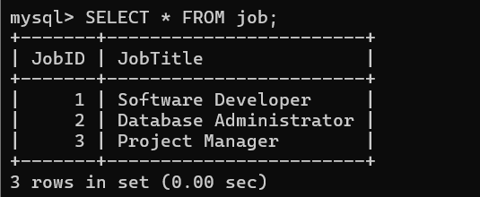
- Case: Library(MemberID, MemberName, BookID, Title, Author, Genre, BorrowDate). Identify MVDs and decompose to 4NF.

ANSWER:

MVDs:
- MemberID →→ BookID
- BookID →→ Author
Decomposition:
- Member(MemberID, MemberName)
- Book(BookID, Title, Genre)
- Borrow(MemberID, BookID, BorrowDate)
- BookAuthor(BookID, Author)
Answer: Multivalued dependencies are separated; the design is in 4NF

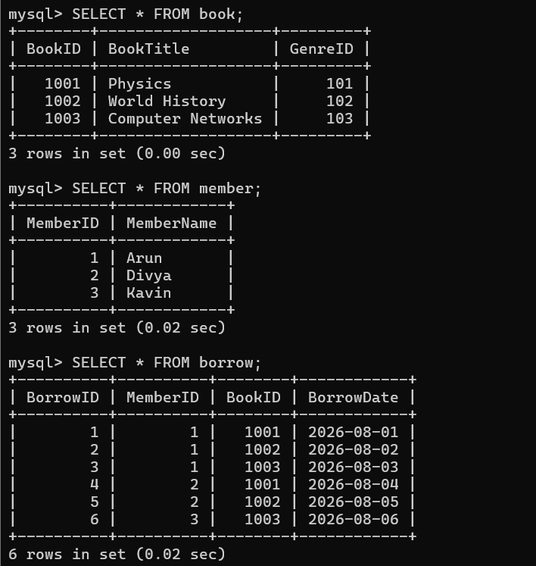
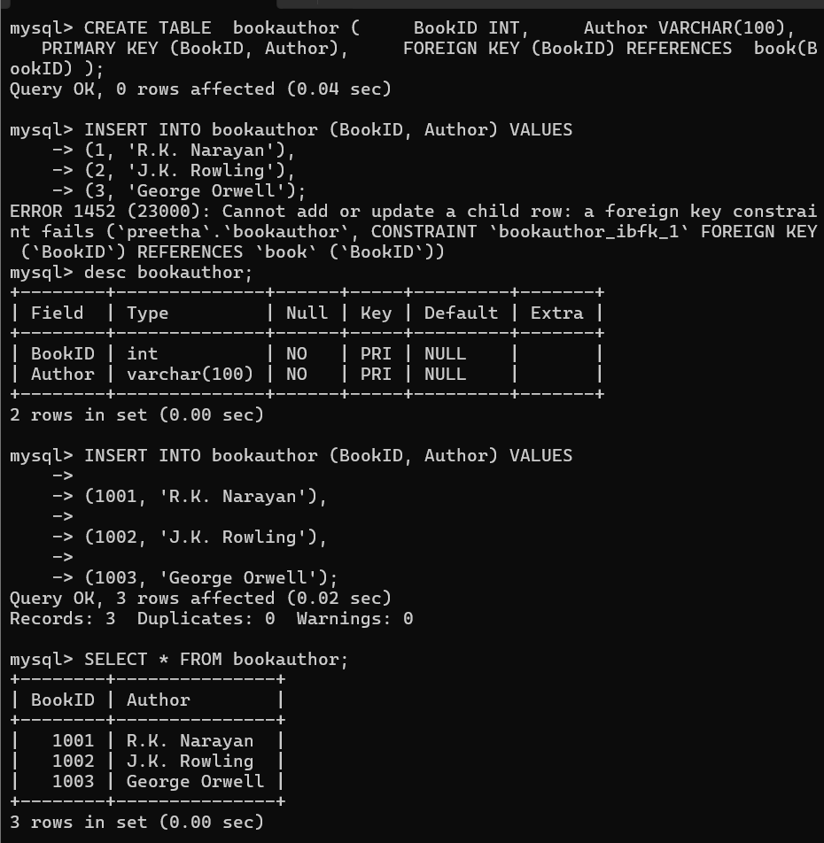

- Analyze a telecom billing schema and identify all candidate keys, primary keys, and functional dependencies before normalization.

ANSWER:

Telecom Billing
Candidate Keys:
- BillID
- CallID
Primary Key:
- BillID
FDs:
- BillID → CustomerID, PhoneNo, PlanID
- CustomerID → CustomerName
- PlanID → PlanName
- CallID → BillID, CallDuration, Charge
Decomposition:
- Customer(CustomerID, CustomerName, PhoneNo)
- Plan(PlanID, PlanName)
- Bill(BillID, CustomerID, PlanID)
- Call(CallID, BillID, CallDuration, Charge)
Answer: Candidate keys and functional dependencies are identified before normalization.
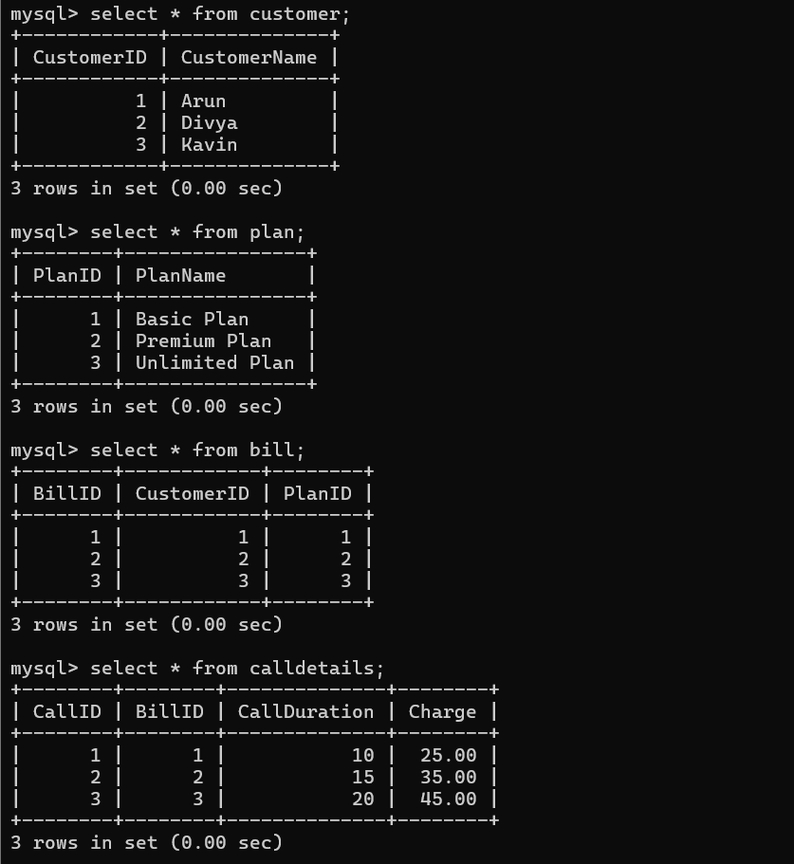

- A retail inventory system has Product(PID, PName, SupplierID, SupplierName, Category, Price, Warehouse). Apply complete normalization.

ANSWER:

FDs:
- PID → PName, SupplierID, Category, Price, Warehouse
- SupplierID → SupplierName
Transitive Dependency:
- PID → SupplierID → SupplierName
Decomposition:
- Product(PID, PName, SupplierID, Category, Price, Warehouse)
- Supplier(SupplierID, SupplierName)
Answer: Transitive dependency is removed; the relation is in 3NF.

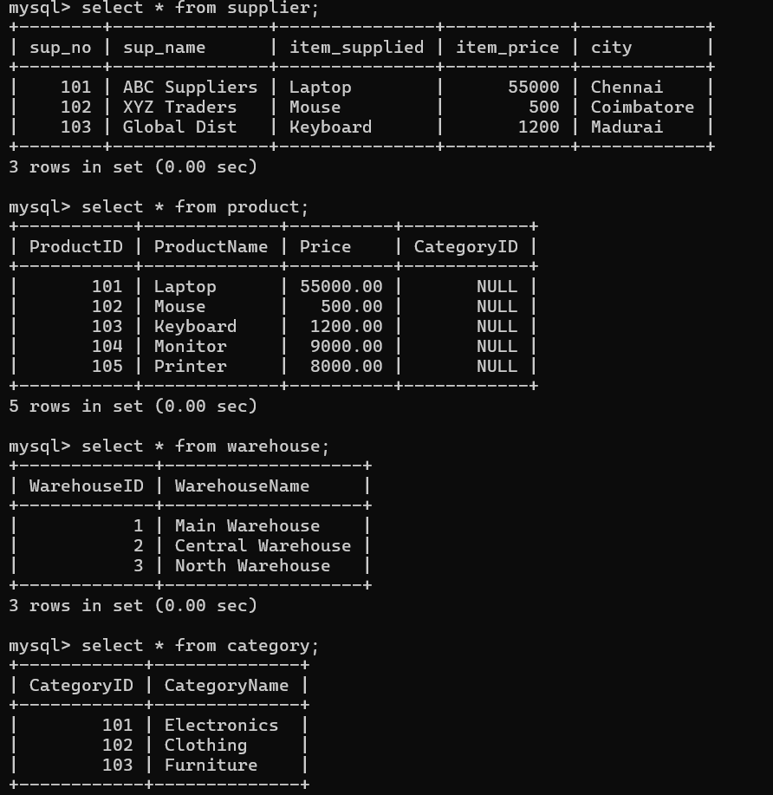

- Study the given poorly normalized schema for a School ERP and propose a fully normalized design up to BCNF with justification.

ANSWER:

School ERP — BCNF
FDs:
- SID → SName, ClassID
- ClassID → ClassName, TeacherID
- TeacherID → TeacherName
- SubjectID → SubjectName
- (SID, SubjectID) → Marks
Decomposition:
- Student(SID, SName, ClassID)
- Class(ClassID, ClassName, TeacherID)
- Teacher(TeacherID, TeacherName)
- Subject(SubjectID, SubjectName)
- StudentMarks(SID, SubjectID, Marks)
Answer: Transitive dependencies are removed and the relations satisfy BCNF.

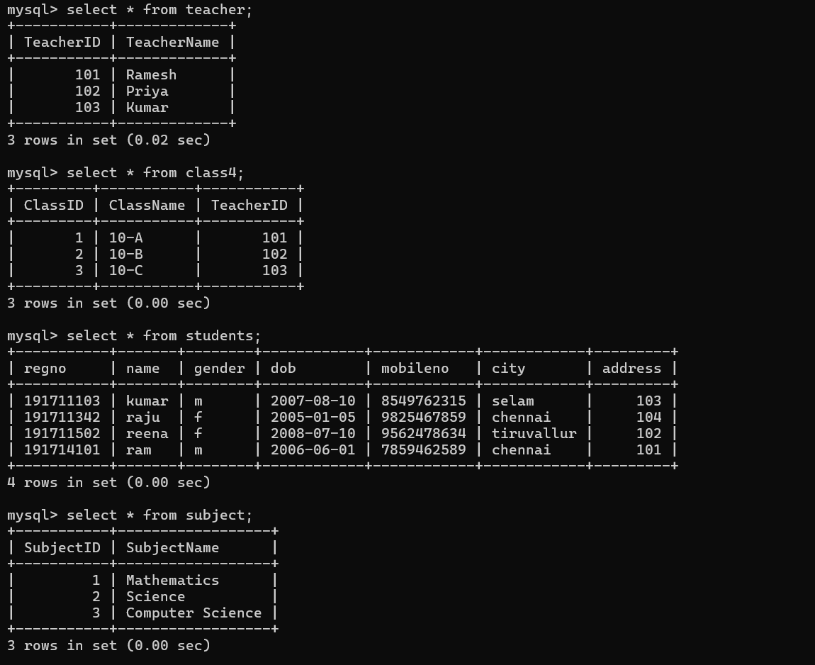
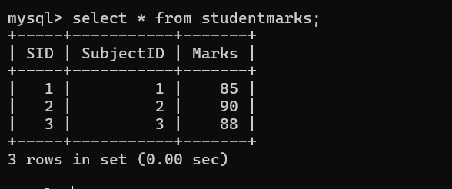

- Given a movie streaming platform schema, identify join dependencies and decompose to 5NF with lossless-join verification.

ANSWER:

Movie Streaming — 5NF
Join Dependency:
MovieStreaming = MovieActor ⋈ MovieDirector
Decomposition:
- Movie(MovieID, MovieName)
- Actor(ActorID, ActorName)
- Director(DirectorID, DirectorName)
- MovieActor(MovieID, ActorID)
- MovieDirector(MovieID, DirectorID)
Lossless Join:
SELECT MA.MovieID, MA.ActorID, MD.DirectorID
FROM MovieActor MA
JOIN MovieDirector MD
ON MA.MovieID = MD.MovieID;
Answer: The join dependency is decomposed into independent relations, giving 5NF with lossless reconstruction.

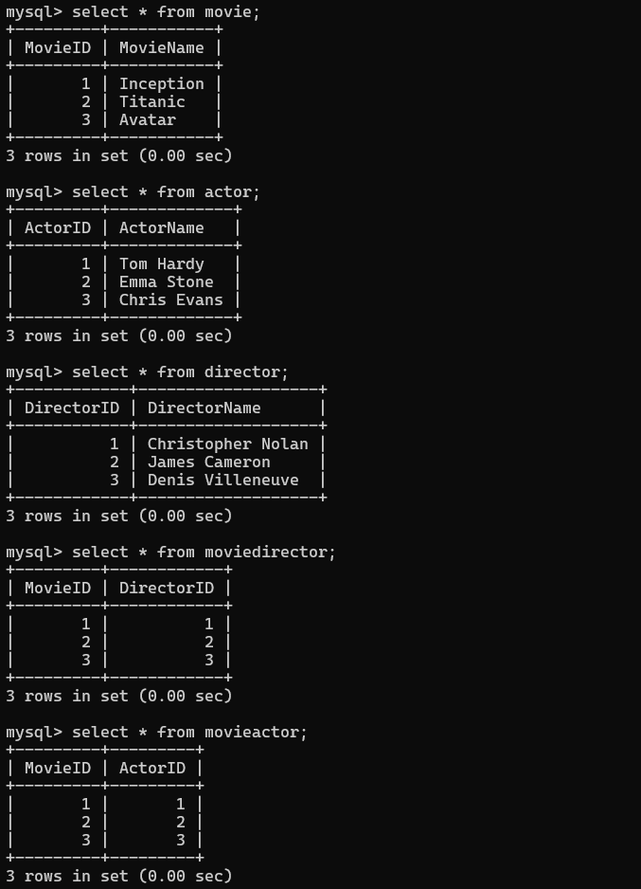

Code of Conduct:

I _M.V.PREETHASHRI(192524476)_ (Name / Reg No) certify that this submission is my original work and that I have adhered to the guidelines specified for this assessment.
I understand that any violation of academic integrity rules will result in disciplinary action.

Signature of the student: M.V.PREETHASHRI

